Should Microsoft’s Monopoly be regulated?



By Saral Kaushik
Candidate Number: ****
Centre Number: *****
Contents

Contents 2
Should Microsoft’s monopoly be regulated? 3
Appendix 1: Bibliography 8
Appendix 2: Microsoft’s Windows OS global market share is more than 97% according to OneStat. 9
Appendix 2: Data Collected by netcraft 9
Appendix 3: Data collected by w3schools 10

Methodology

I conducted this investigation by using the internet to look a range of information, I searched news sites for information regarding the EU’s ruling over Microsoft’s bundling of Windows Media Player, and also for information about anti-trust rulings that Microsoft had in the past.

Through looking at all this information, and drawing upon my own background knowledge of the computing industry, I
Should Microsoft’s monopoly be regulated?

Microsoft is a software giant; they create a lot of software, but are probably most famous for their Windows Operating system.
Windows ships in three main forms, desktop use, server use and mobile use.

Recently there was an EU ruling against Microsoft, ordering Microsoft to remove Windows Media Player from new copies of Windows XP, because it was considered anti-competitive for other companies who wanted to offer media players to Windows users, as being provided with a media player would mean they do not have an incentive to download a different media player.

Figure 1 - Market share of desktop operating systems, Source - onestat.com

This graph shows that Microsoft dominates the desktop operating system market, with over 97% market share, which is definitely a monopoly.

Apple’s market share of 1.43% means they do not benefit from economies of scale, and so they have to operate either with high priced products, or low profit margins.

Linux is hard to compare, since it is open source and a lot of Linux Operating Systems are free.

In server operating systems market segment however, Linux-Apache systems, which are cheaper (usually free) and designed for use on servers, have a much higher market share than Windows, as can be seen in this graph;

Figure 2 - Market share of Server operating systems, Source: netcraft

By looking at these two graphs, we can see that Microsoft has a monopoly in the Home server market segment.

According to PC Magazine, Apple (Microsoft’s only true desktop OS competitor, Linux is geared towards server use) finds it hard to gain a higher market share because their cost base is too high. Since, on a technical side, Macintosh PCs use a completely different computer architecture form Windows, most of their hardware has to be specially made, and since the manufacturers are building these parts in small quantities, the cost per unit will be high, combined with Apple’s high profit margins, this would end in a higher price for the consumer.

Many companies complain that Microsoft’s monopoly enables them to command the prices, and this will lead to high prices for their operating system and other software by them, however this is not the case. As you can see from the graphs below, the presence of Microsoft within the Spreadsheet and Word Processing (SS and WP) markets, which are the two biggest software markets, has caused the prices to fall.
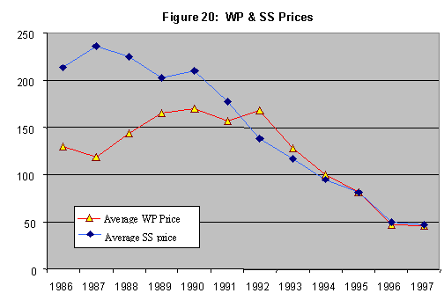
Figure 3 - Source - http://www.utdallas.edu/~liebowit/book/msmonopoly.html

As you can see the average price has fallen, because of competition from Lotus and Word Perfect.

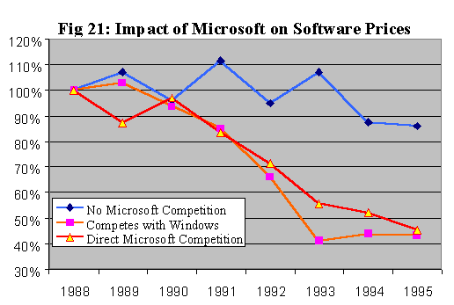
Figure 4

From this graph, you can see that Markets that Microsoft compete in, force prices to be lowered.

So as we can see, Microsoft’s monopoly does not cause prices to rise, in fact, it causes the reverse. The presence of Microsoft in certain markets has caused the average price of software within that market to fall.

The main reasons why people want Microsoft’s monopoly to be regulated is because of their bundling of web browsers.

With browsers, there are only three browser engines that are complete enough to compete as a primary browser; Microsoft Internet Explorer, Firefox (based on Netscape) and Opera.

Figure 5 – Market share of browsers, Source - w3cschools.com

As you can see from this graph, while Microsoft’s browser still maintains a high percentage of users, its market share is decreasing and the open-source browser Firefox is gaining on Microsoft’s monopoly of web browsers. This is because Internet Explorer has reached maturity on its product life cycle, and Microsoft has not employed any extension strategies, whereas the newer browsers such as Opera and Firefox have more features, like tabbed browsing and increased security giving them a competitive advantage over the aged Internet Explorer.

So, should Microsoft’s monopoly be regulated?

In some ways, it should, by looking at the market share in operating systems; there is clear evidence that Microsoft’s monopoly is affecting other companies such as Apple. However, Microsoft’s monopoly is fairly limited to that of desktop operating systems; it does not have a significant market share in server operating systems and there is evidence to suggest that Microsoft is slowly losing its monopoly of web browsers to Firefox. Apple controls most of the music market. And evidence suggests that the monopoly is actually benefiting consumers.

So the question is not should the monopoly be regulated, but how?

The regulators must strike a balance between helping competitors, and consumers, if they get it wrong it could mean that Microsoft loses its monopoly and the price of products would go up, as seen above.

However, it is slightly complicated by the nature of Microsoft’s competition, Apple is more of a vertically integrated company, that is to say that it creates everything for the PC, it assembles the hardware and all the parts, and then sells the product, but Microsoft is a horizontally integrated company, i.e. just makes the software and then other companies use it on their PCs. So in some ways, Microsoft doesn’t have any competitors in the same market. Since Linux, at the moment is not a viable option for desktop PCs, computer manufacturers don’t have any other choice as to what software they use with their PCs. Therefore, regulations on Microsoft, i.e. forcing Microsoft to charge more for their Operating System, would just mean a general increase in the price of computers, since manufacturers would have no choice but to accept these price increases and pass it on to consumers.

In conclusion, through looking at all the data, we can conclude the following.

- Microsoft only has a significant market share in the desktop market.
- Its monopoly on Word Processing and Spread Sheet software is beneficial to consumers
- Microsoft is losing its monopoly in web browsers despite IE being bundled with Windows

So, considering this, I conclude that while Microsoft does have a monopoly, there is enough evidence to suggest that the monopoly is fairly limited and does not need to be regulated.

998 Words

Appendix 1: Bibliography

I got my data from the following sources.

Figure 1 – The data was taken from http://www.onestat.com, a company that specialises in software that analysis information regarding your website’s demographics. The provided a table with the information, and I used that to construct the graph.

Figure 2 – This data was provided by http://www.netcraft.com, they collected data from 60 million websites over a space of 10 years to construct raw charts about what servers websites were running. Again, I used a table they provided, to create a

Figures 3 & 4 – These were both taken from http://www.utdallas.edu/~liebowit/book/msmonopoly.html, a study into the affect Microsoft had on the market.

Figure 5 – This was taken from http://www.w3schools.com, a free library of information that focuses on the development of web standards. They placed trackers on a range of different websites, that would collect information about what web browser people used. They provided a table, and I constructed a graph from that.

I took some definitions from http://www.bized.ac.uk/glossary/glossary.htm.

Appendix 2: Microsoft’s Windows OS global market share is more than 97% according to OneStat.

Amsterdam - September 10 2002 - OneStat.com ( http://www.onestat.com ), the number one provider of real-time website analysis software, today reported that Microsoft's Windows operating system has a global usage share of 97.46 percent. Microsoft's Windows still dominates the global operating system market. The global usage share of Apple's Macintosh operating system is 1.43 percent and is the second most popular operating system in the world.

"Our software is the ultimate solution to measure the operating systems from your web site visitors" said Niels Brinkman, co-founder of OneStat.com.

The 3 most popular operating systems are:

1. Windows 97.46%
2. Macintosh 1.43%
3. Linux 0.26%

All numbers are an average of the last 2 months. OneStat.com is the number one provider of real-time website analysis software in the world. Our superior technology powers thousands of websites in different countries all over the world. With our accurate, detailed & reliable reports we will be able to answer questions about visitor behaviour, site performance and retention.

http://www.onestat.com/html/aboutus_pressbox10.html

Appendix 2: Data Collected by netcraft

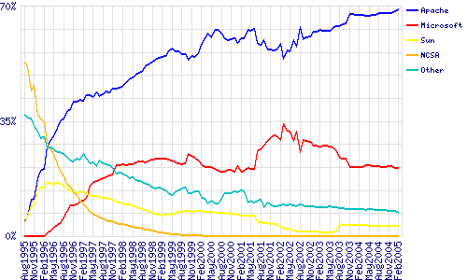

This data was collected by netcraft over 10 years. It shows the percentage of servers that use certain server software.

This table was also provided.

Developer | Jan-05 | Percent | Feb-05 | Percent | Change
Apache | 39821368 | 68.43 | 40681140 | 68.83 | 0.4
Microsoft | 12137446 | 20.86 | 12322111 | 20.85 | -0.01
Sun | 1830008 | 3.14 | 1835718 | 3.11 | -0.03
Zeus | 690193 | 1.19 | 618599 | 1.05 | -0.14

http://news.netcraft.com/archives/web_server_survey.html

Appendix 3: Data collected by w3schools

2005 | IE 6 | IE 5 | O 7/8 | Ffox | Moz | NN 4 | NN 7
March | 64.00% | 3.90% | 1.80% | 21.50% | 3.70% | 0.20% | 1.00%
February | 64.80% | 4.20% | 1.90% | 20.40% | 3.90% | 0.20% | 1.10%
January | 65.30% | 4.40% | 2.10% | 19.30% | 4.00% | 0.30% | 1.10%
2004 | IE 6 | IE 5 | O 7 | Moz | NN 3 | NN 4 | NN 7
December | 66.00% | 4.80% | 2.00% | 21.30% | 0.20% | 0.30% | 1.20%
November | 68.50% | 5.00% | 2.20% | 19.30% | 0.20% | 0.20% | 1.20%
October | 69.50% | 5.70% | 2.20% | 17.50% | 0.20% | 0.20% | 1.30%
September | 69.60% | 6.20% | 2.30% | 16.90% | 0.20% | 0.20% | 1.30%
August | 70.30% | 7.00% | 2.30% | 15.50% | 0.30% | 0.30% | 1.40%
July | 71.00% | 7.70% | 2.30% | 13.80% | 0.30% | 0.30% | 1.40%
June | 72.40% | 8.30% | 2.30% | 11.80% | 0.30% | 0.30% | 1.40%
May | 72.60% | 9.20% | 2.20% | 11.00% | 0.30% | 0.30% | 1.40%
April | 72.40% | 10.10% | 2.10% | 10.30% | 0.30% | 0.30% | 1.40%
March | 72.10% | 10.70% | 2.10% | 9.60% | 0.40% | 0.40% | 1.40%
February | 71.50% | 11.50% | 2.20% | 9.00% | 0.40% | 0.40% | 1.50%
January | 71.30% | 12.80% | 2.10% | 8.20% | 0.40% | 0.50% | 1.50%
2003 | IE 6 | IE 5 | O 7 | Moz | NN 3 | NN 4 | NN 7
November | 71.20% | 13.70% | 1.90% | 7.20% | 0.50% | 0.50% | 1.60%
September | 69.70% | 16.90% | 1.80% | 6.20% | 0.60% | 0.60% | 1.50%
July | 66.90% | 20.30% | 1.70% | 5.70% | 0.60% | 0.60% | 1.50%
May | 65.00% | 22.70% | 1.40% | 4.60% | 1.00% | 0.90% | 1.40%
March | 63.40% | 24.60% | 1.20% | 4.20% | 0.90% | 1.10% | 1.40%
January | 55.30% | 29.30% |  | 4.00% | 1.20% | 1.70% | 1.10%
2002 | IE 6 | IE 5 | IE 4 | AOL | NN 3 | NN 4 | NN 5+
November | 53.50% | 29.90% |  | 5.20% | 1.10% | 2.00% | 4.90%
September | 49.10% | 34.40% |  | 4.50% | 1.30% | 2.20% | 4.50%
July | 44.40% | 40.10% | 0.50% | 3.50% | 1.20% | 2.60% | 3.50%
May | 40.70% | 46.00% | 0.70% | 2.80% | 1.20% | 3.40% | 2.70%
March | 36.70% | 49.40% | 0.70% | 3.00% | 1.20% | 4.10% | 2.40%
January | 30.10% | 55.70% | 1.00% | 2.80% | 1.30% | 4.40% | 2.20%

IE Internet Explorer
Ffox Firefox (identified as Mozilla before 2005)
Moz Mozilla
O Opera
NN Netscape
AOL America Online (based on both Internet Explorer and Mozilla)

The proportion of sales a certain brand has within a certain market.
In the UK, a market share of more than 25% is considered a monopoly.
The cost benefits associated with increasing the size of a company, i.e. Bulk discounts.
Software in which the coding is available for free, so other parties can develop it.
A group of consumers in a market.
The total cost of making a product (Variable Costs + Fixed Costs) divided by the total amount produced.
The profit as a percentage of turnover.
The point on a product life cycle where the product is reaching its peak in sales
The various stages a product experiences during its life, starting from the initial boom of people buying it, down to the decline of sales towards the end.
Techniques to try and delay a product from progressing along the product life cycle, for example remarketing, or updating the product.
Something that gives a company an advantage to sell their product at a lower price, or with increased demand.
A company that incorporates different stages of the production chain.
A company which incorporates different companies of the same market at the same point in the production chain.

